|  |
| --- |
| Описание: Описание: для прик эмбл |
| МИНОБРНАУКИ РОССИИ |
| Федеральное государственное бюджетное образовательное учреждениевысшего профессионального образования"Российский технологический университет"МИРЭА |
| Институт «Комплексной безопасности и специального приборостроения» |
| Кафедра «Управление и моделирование систем» (КБ-3) |
|  |

|  |  |
| --- | --- |
| **Практическое занятие № 3**  «Метаданные» | |
|  | |
|  | |
|  | |
| Выполнила студентка группы БИСО-03-19 | *Васильева С. А.* |

Москва 2020

**Задание 1**

Фото



|  |  |
| --- | --- |
| **create** | 2020-11-18T17:32:34+00:00 |
| ApertureValue | 200/100 |
| ColorSpace | 1 |
| Compression | 6 |
| DateTime | 2020:11:18 20:15:14 |
| DateTimeDigitized | 2020:11:18 20:15:14 |
| DateTimeOriginal | 2020:11:18 20:15:14 |
| DigitalZoomRatio | 100/100 |
| ExifImageLength | 3000 |
| ExifImageWidth | 4000 |
| ExifOffset | 238 |
| ExifVersion | 48, 50, 50, 48 |
| ExposureBiasValue | 0/100 |
| ExposureMode | 0 |
| ExposureProgram | 2 |
| ExposureTime | 1/20 |
| Flash | 0 |
| FNumber | 200/100 |
| FocalLength | 460/100 |
| FocalLengthIn35mmFilm | 25 |
| GPSInfo | 636 |
| GPSLatitude | 56/1, 5/1, 25779120/1000000 |
| GPSLatitudeRef | N |
| GPSLongitude | 47/1, 16/1, 38044199/1000000 |
| GPSLongitudeRef | E |
| ImageLength | 3000 |
| ImageUniqueID | B48LSMG00CM |
| ImageWidth | 4000 |
| ISOSpeedRatings | 1000 |
| JPEGInterchangeFormat | 856 |
| JPEGInterchangeFormatLength | 35855 |
| Make | samsung |
| MaxApertureValue | 200/100 |
| MeteringMode | 3 |
| Model | SM-A515F |
| Orientation | 6 |
| ResolutionUnit | 2 |
| SceneCaptureType | 0 |
| ShutterSpeedValue | 1/20 |
| Software | A515FXXU4CTJ1 |
| WhiteBalance | 0 |
| XResolution | 72/1 |
| YCbCrPositioning | 1 |
| YResolution | 72/1 |
| **modify** | 2020-11-18T17:32:34+00:00 |
| ApertureValue | 200/100 |
| ColorSpace | 1 |
| Compression | 6 |
| DateTime | 2020:11:18 20:15:14 |
| DateTimeDigitized | 2020:11:18 20:15:14 |
| DateTimeOriginal | 2020:11:18 20:15:14 |
| DigitalZoomRatio | 100/100 |
| ExifImageLength | 3000 |
| ExifImageWidth | 4000 |
| ExifOffset | 238 |
| ExifVersion | 48, 50, 50, 48 |
| ExposureBiasValue | 0/100 |
| ExposureMode | 0 |
| ExposureProgram | 2 |
| ExposureTime | 1/20 |
| Flash | 0 |
| FNumber | 200/100 |
| FocalLength | 460/100 |
| FocalLengthIn35mmFilm | 25 |
| GPSInfo | 636 |
| GPSLatitude | 56/1, 5/1, 25779120/1000000 |
| GPSLatitudeRef | N |
| GPSLongitude | 47/1, 16/1, 38044199/1000000 |
| GPSLongitudeRef | E |
| ImageLength | 3000 |
| ImageUniqueID | B48LSMG00CM |
| ImageWidth | 4000 |
| ISOSpeedRatings | 1000 |
| JPEGInterchangeFormat | 856 |
| JPEGInterchangeFormatLength | 35855 |
| Make | samsung |
| MaxApertureValue | 200/100 |
| MeteringMode | 3 |
| Model | SM-A515F |
| Orientation | 6 |
| ResolutionUnit | 2 |
| SceneCaptureType | 0 |
| ShutterSpeedValue | 1/20 |
| Software | A515FXXU4CTJ1 |
| WhiteBalance | 0 |
| XResolution | 72/1 |
| YCbCrPositioning | 1 |
| YResolution | 72/1 |
| **colorspace** | 2 |
| ApertureValue | 200/100 |
| ColorSpace | 1 |
| Compression | 6 |
| DateTime | 2020:11:18 20:15:14 |
| DateTimeDigitized | 2020:11:18 20:15:14 |
| DateTimeOriginal | 2020:11:18 20:15:14 |
| DigitalZoomRatio | 100/100 |
| ExifImageLength | 3000 |
| ExifImageWidth | 4000 |
| ExifOffset | 238 |
| ExifVersion | 48, 50, 50, 48 |
| ExposureBiasValue | 0/100 |
| ExposureMode | 0 |
| ExposureProgram | 2 |
| ExposureTime | 1/20 |
| Flash | 0 |
| FNumber | 200/100 |
| FocalLength | 460/100 |
| FocalLengthIn35mmFilm | 25 |
| GPSInfo | 636 |
| GPSLatitude | 56/1, 5/1, 25779120/1000000 |
| GPSLatitudeRef | N |
| GPSLongitude | 47/1, 16/1, 38044199/1000000 |
| GPSLongitudeRef | E |
| ImageLength | 3000 |
| ImageUniqueID | B48LSMG00CM |
| ImageWidth | 4000 |
| ISOSpeedRatings | 1000 |
| JPEGInterchangeFormat | 856 |
| JPEGInterchangeFormatLength | 35855 |
| Make | samsung |
| MaxApertureValue | 200/100 |
| MeteringMode | 3 |
| Model | SM-A515F |
| Orientation | 6 |
| ResolutionUnit | 2 |
| SceneCaptureType | 0 |
| ShutterSpeedValue | 1/20 |
| Software | A515FXXU4CTJ1 |
| WhiteBalance | 0 |
| XResolution | 72/1 |
| YCbCrPositioning | 1 |
| YResolution | 72/1 |
| **sampling-factor** | 2x2,1x1,1x1 |
| ApertureValue | 200/100 |
| ColorSpace | 1 |
| Compression | 6 |
| DateTime | 2020:11:18 20:15:14 |
| DateTimeDigitized | 2020:11:18 20:15:14 |
| DateTimeOriginal | 2020:11:18 20:15:14 |
| DigitalZoomRatio | 100/100 |
| ExifImageLength | 3000 |
| ExifImageWidth | 4000 |
| ExifOffset | 238 |
| ExifVersion | 48, 50, 50, 48 |
| ExposureBiasValue | 0/100 |
| ExposureMode | 0 |
| ExposureProgram | 2 |
| ExposureTime | 1/20 |
| Flash | 0 |
| FNumber | 200/100 |
| FocalLength | 460/100 |
| FocalLengthIn35mmFilm | 25 |
| GPSInfo | 636 |
| GPSLatitude | 56/1, 5/1, 25779120/1000000 |
| GPSLatitudeRef | N |
| GPSLongitude | 47/1, 16/1, 38044199/1000000 |
| GPSLongitudeRef | E |
| ImageLength | 3000 |
| ImageUniqueID | B48LSMG00CM |
| ImageWidth | 4000 |
| ISOSpeedRatings | 1000 |
| JPEGInterchangeFormat | 856 |
| JPEGInterchangeFormatLength | 35855 |
| Make | samsung |
| MaxApertureValue | 200/100 |
| MeteringMode | 3 |
| Model | SM-A515F |
| Orientation | 6 |
| ResolutionUnit | 2 |
| SceneCaptureType | 0 |
| ShutterSpeedValue | 1/20 |
| Software | A515FXXU4CTJ1 |
| WhiteBalance | 0 |
| XResolution | 72/1 |
| YCbCrPositioning | 1 |
| YResolution | 72/1 |
|  |  |

**Задание 2**

Выбран сайт **nature.com**





**Задание 3**

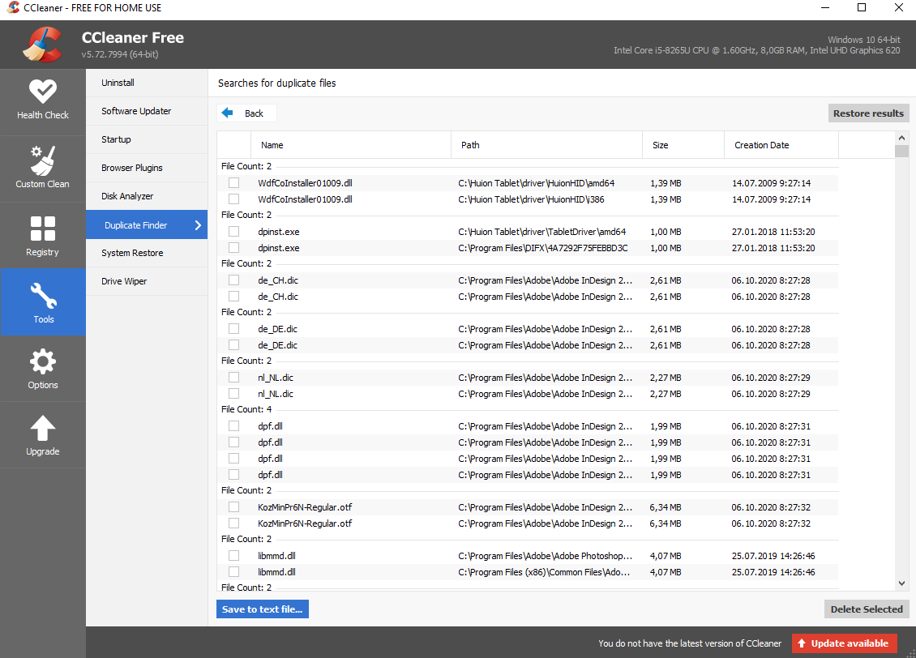

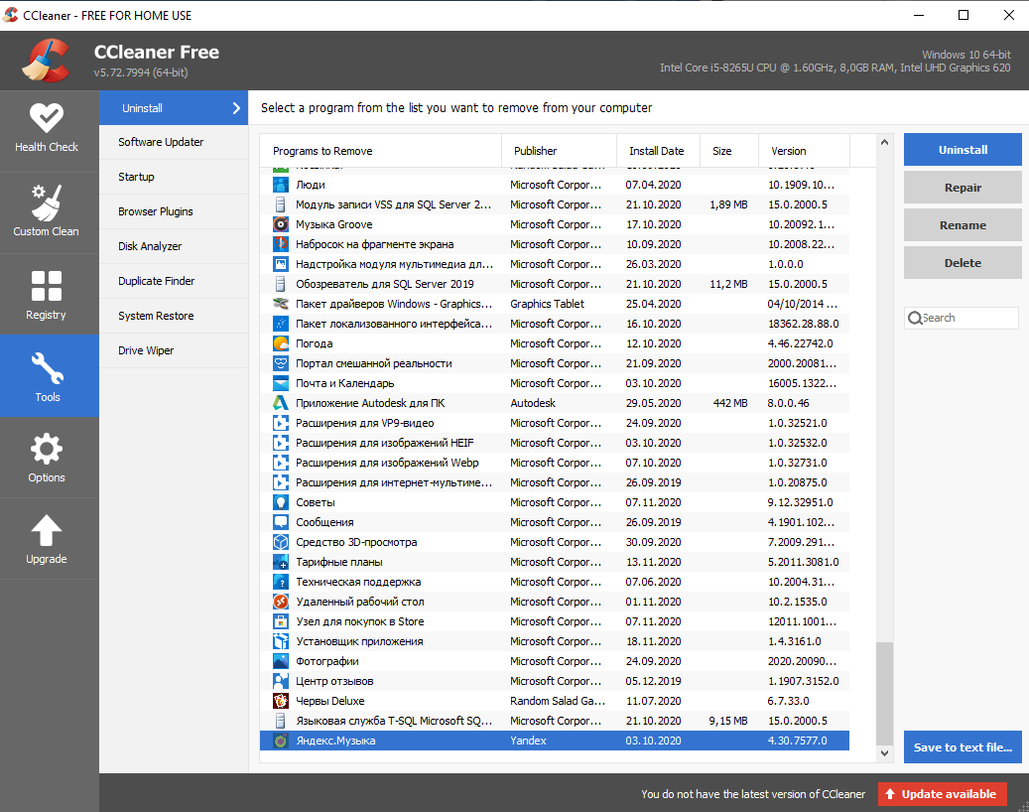

Удалено приложение Яндекс Музыка

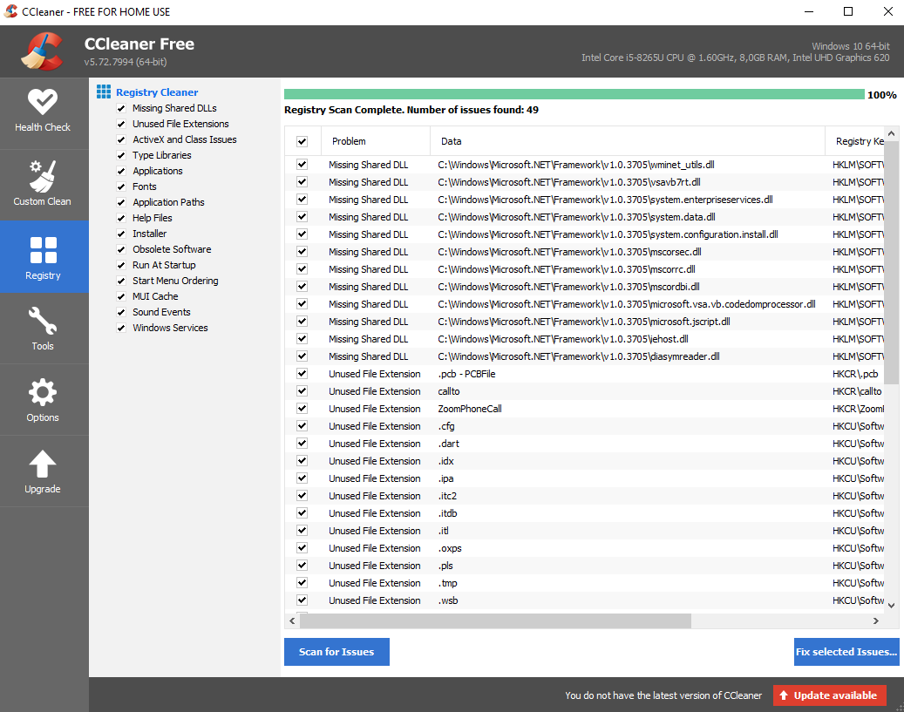

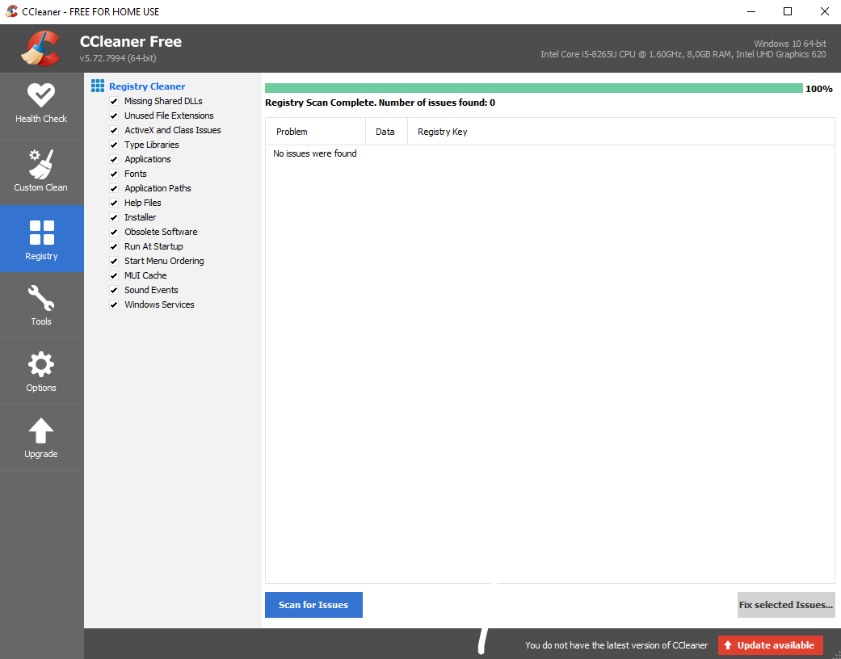

**Задание 4**

Создан и удален файл Microsoft Word